1. **Step 1. Magnifying Risk**
   1. **Student: Oratile - Personal unsecured loan at fixed rate Credit card Risk**

|  |  |  |
| --- | --- | --- |
|  | **LEVERAGE** | **NON-LINEARITY** |
| **CREDIT CARD LOANS** | High interest rates:  Credit card loans often have relatively high interest rates, especially if the balance is not paid in full each month. When individuals use credit card debt to invest or make purchases, they are actually borrowing at high interest rates. If investments or purchases do not generate returns greater than the interest on credit card debt, they may incur significant interest charges.  Amplifier loss:  Leverage can magnify both profits and losses. While this has the potential to increase returns when investments perform well, it can also lead to larger losses if the value of the investment falls. If a person has borrowed a large amount of money on a credit card and invested it in a volatile asset, such as stocks, a market downturn can lead to significant losses.  Debt accumulation:  Continuously relying on credit cards for leverage can lead to a cycle of debt accumulation. If individuals are unable to pay off their credit card balances in full and continue to borrow for investments or purchases, debt can increase rapidly, causing financial hardship and potentially harming scores. Their credit.  Impact on credit score:  Having a high credit card balance relative to their credit limit, known as a high credit utilization ratio, can negatively impact an individual's credit score. A lower credit score can lead to higher interest rates on future credit card loans and difficulty obtaining other types of credit. Minimum payment trap:  Credit cards typically only require minimum monthly payments, usually a small percentage of the outstanding balance. If individuals use credit cards as leverage and only make minimum payments, paying off the debt can take a long time and the interest rates can be huge. | Credit scoring model:  Credit card issuers often use a credit scoring model to evaluate an applicant's creditworthiness. These models use a variety of factors such as credit score, income, and employment history and debt level to estimate the probability of default. Non-linear risk can arise when the relationship between these factors and credit risk is not straightforward. For example, a small change in an applicant's credit score may not have a linear impact on their likelihood of default.  Behavioral factors:  Credit card borrower behavior can be non-linear and unpredictable. For example, a borrower who has previously made on-time payments may suddenly default due to an unexpected life event, such as a medical emergency or job loss. This type of non-linear behavior can be difficult for lenders to predict and manage.  Economic conditions:  Non-linear risks can also appear during economic downturns. During a recession, the relationship between factors such as the unemployment rate and credit card default rates can be nonlinear. Credit card issuers may experience disproportionate levels of defaults, even with relatively small increases in the unemployment rate. Focus your investment portfolio:  If a credit card issuer has a significant concentration of credit card loans in a particular segment (e.g., subprime borrowers), the risk of non-linearity may become more apparent. Indeed, the credit risk associated with subprime borrowers can be very sensitive to economic conditions and other factors.  Credit limit management:  Credit card issuers often adjust cardholders' credit limits based on their credit behavior and financial situation. Non-linear risks can arise when these adjustments do not have a linear impact on the borrower's ability to manage debt. For example, reducing a borrower's credit limit does not necessarily reduce their default risk proportionately. |

* 1. **Student Oratile - Personal unsecured loan at floating rate Car loan or home loan risk**

|  |  |  |
| --- | --- | --- |
|  | **LEVERAGE** | **NON-LINEARITY** |
| **HOME OR AUTO-MOBILE LOAN** | Interest rate:  When you borrow money to buy a house or car, you usually have to pay interest on the loan. Leverage risk appears when lending interest rates are high. High interest rates can significantly increase financing costs, making home or car ownership more expensive over time.  Monthly payment:  Taking advantage of a home or car purchase can result in higher monthly loan payments. If your financial situation changes, such as losing your job or unexpected expenses, you may have difficulty meeting these monthly payments, which could lead to default or financial difficulties. Depreciation:  Cars, in particular, tend to lose value over time. If you borrow a large amount of money to buy a car and its value depreciates rapidly, you may find yourself owing more on the loan than the car is worth. This is called being “underwater” on your loan, and it can pose a significant financial risk if you need to sell or trade in the vehicle.  House value fluctuations:  Home values ​​can also fluctuate. If you take out a mortgage to buy a home and the housing market declines, the value of your home could drop below the amount you owe on your mortgage. This can make it difficult to sell your home or refinance your mortgage.  Credit risk:  If you use leverage to finance a house or a car, you are taking on debt. Failure to make timely loan payments can negatively impact your credit score, making borrowing more difficult and expensive in the future.  Loan conditions:  Loan terms can also introduce leverage risk. For example, adjustable-rate mortgages (ARMs) may result in higher monthly payments if interest rates increase. Balloon payments, where you receive a large lump sum payment at the end of the loan term, can also be a form of leverage risk. | Interest rate:  Non-linear risk can be especially relevant when it comes to interest rates. Small changes in interest rates can have a significant impact on loan affordability. For example, a small increase in interest rates could cause some borrowers to default on their previous mortgage or auto loans, leading to higher default rates.  Real estate and automobile market:  Nonlinearity can also apply to the real estate and auto markets themselves. In a rapidly rising market, borrowers may assume that the value of their home or car will continue to rise, leaving them with more debt than they can handle. However, if the market changes suddenly, the value of these assets could decline, leaving the borrower with a loan larger than the value of the underlying collateral.  Lending practices:  Lenders can also contribute to non-linear risk by offering loans with variable interest rates or loans that only allow interest payments over a certain period of time. These features may initially make loans more affordable, but can result in much higher payments as interest rates increase or principal payments take effect.  Economic factors:  Non-linearity risks may become more severe during economic downturns. For example, during a recession, job losses can have a disproportionate impact on a borrower's ability to repay debt. This could lead to a greater increase in defaults than would be predicted by a simple linear model.  Regulation changes:  Changes in regulations related to lending activities can also create non-linear risks. For example, new regulations restricting certain lending activities or requiring stricter underwriting standards could suddenly limit borrowers' access to credit, leading to changes surprise in lending efficiency.  Behavioral factors:  Human behavior can also cause non-linear risk. Borrowers may make financial decisions based on their emotions or speculative beliefs about the housing or auto markets, which can lead to non-linear outcomes. |

* 1. **Student: Ebenezer Construction Business loan at fixed rate Risk**

|  |  |  |  |  |
| --- | --- | --- | --- | --- |
| **Table 1** | | | **Magnifying Risk** | |
| **Leverage Challenges** | **Non-linearity Challenges** |
| **Scenario** | **3** | **Money at a fixed rate for a business for a construction loan** | * **Interest Rate Risk**: If market interest rates decline significantly after taking the loan, the fixed-rate loan could become relatively more expensive compared to what the business could have secured at the prevailing market rates. This can affect the business's ability to meet its interest payment obligations. * **Debt Servicing**: The business must generate sufficient cash flow to cover both the principal and interest payments on the construction loan. Leverage can be challenging if the business's cash flow is insufficient to meet these debt service requirements, especially during the construction phase when revenue generation may be limited | * **Unforeseen Contingencies**: Non-linear challenges can also emerge from unforeseen contingencies, such as legal disputes, environmental issues, or supply chain disruptions. These contingencies can disrupt project timelines and escalate costs unexpectedly. |

* 1. **Student: Yhasreen for bond and equity magnifying risk.**

|  |  |  |  |  |
| --- | --- | --- | --- | --- |
| **Table 1** | | | **Magnifying Risk** | |
| **Investing’s Consideration** | **Investing Consideration** |
| **Leverage Risk** | **Non-Linearity Risk** |
| **Security Lending Scenarios** | **4** | **AAPL**  **Equity Investment** | 1. **Compounded Losses:** Leveraging investments involves borrowing money to invest more than what one can afford with just their capital. Leverage to invest amplifies their potential returns and losses. If an investor uses 2:1 leverage by borrowing an equal amount to what they are investing and the stock price falls by 10%, the investor loses 20%, excluding borrowing costs. The actual amount of equity in the investment can decrease rapidly. Compounded losses can quickly erode the investor's capital. 2. **Margin Calls:** If the equity value in the leveraged account falls below a certain threshold of maintenance margin, the broker can issue a margin call, requiring the investor to deposit more money or sell assets to cover the deficit. **[Tickeron]** If the investor fails to meet the margin requirement, the broker can sell the investor's assets at possibly unfavorable prices. **[Futunn]** 3. **Higher Transaction Costs:** Leveraged investments often involve higher transaction fees, interest expenses, and other costs, which can eat into the potential profits. 4. **Interest Rate Risk:** The cost of borrowing can increase if interest rates rise. If an investor has a variable interest rate on borrowed funds, higher interest rates mean higher borrowing costs, which can reduce profitability or increase losses. 5. **Reduced Flexibility:** Leveraged positions may prevent an investor from making portfolio adjustments when they want to, especially in volatile markets where rapid price changes can lead to quick margin calls. 6. **Emotional Pressure:** Leveraged investments can increase emotional stress due to the increased financial risks. Stress leads to poor decision-making based on emotions like fear and greed rather than sound investment analysis. 7. **Currency exchange risk** if the investor’s base currency is not USD. The fluctuations in the USD exchange rate can affect the investment's value and the cost of debt in the investor's local currency. 8. **Liquidity Risk:** In extreme market conditions, specific stocks might have reduced liquidity, making it harder to enter or exit positions. This risk can be more pronounced in a leveraged scenario, as investors are forced to liquidate positions at unfavorable prices. | 1. **Non-linearity risk** is risk associated with financial instruments or investment strategies where the relationship between variables is not linear. Non-linear risk means that a change in one variable does not result in a proportional change in another. Non-linearity emphasizes the importance of diversification. 2. **Price Momentum:** Stocks often do not move linearly. They can have periods of rapid appreciation followed by sharp corrections or stagnate for extended periods only to suddenly move sharply. Various factors can influence price movements, including earnings surprise announcements, product launches, regulatory changes, and broader market dynamics. 3. **Earnings Reactions:** The relationship between a company's earnings surprise (the difference between expected and reported earnings) and its stock price change is often non-linear. A significant earnings miss might lead to a disproportionately large drop in stock price, while a slight earnings beat might not result in any appreciable price change. 4. **Macroeconomic Sensitivities:** The stock's sensitivity to broader economic changes, such as interest rate movements or commodity price fluctuations, may not be linear. For instance, a minor increase in interest rates might have a negligible effect on a stock. In contrast, a substantial increase might have a significant impact due to concerns about borrowing costs and consumer spending. 5. **Liquidity Effects:** In times of market stress or volatility, the liquidity of major stocks like AAPL can change. The relationship between order size (trading volume) and price impact can be non-linear. Large orders might disproportionately move the stock price during less liquid periods. 6. **Behavioral Factors:** Investor sentiment, psychological biases, and herd behavior can introduce non-linearities in stock price movements. For instance, panic selling or FOMO fear of missing out on a buying frenzy can drive prices not based on fundamental valuations. **[yahoofnance]** 7. **Dividend Policy Reactions:** The response of stock prices to changes in dividend policy can be non-linear. A company initiating a significantly changing dividend might see a disproportionate stock price reaction. |

* 1. **Student: Yhasreen for bond and equity magnifying risk**

|  |  |  |  |  |
| --- | --- | --- | --- | --- |
| **Table 1** | | | **Magnifying Risk** | |
| **Investor’s Consideration** | **Investor’s Consideration** |
| **Leverage Risk** | **Non-Linearity Risk** |
| **Security Lending Scenarios** | **5** | **2-year Treasury**  **Bond Investment** | 1. **Opportunity Cost:** The 2-year Treasury bonds are low-risk assets when held to maturity without leverage, but introducing leverage can significantly alter their risk profile. By committing more funds to a leveraged Treasury position, investors might benefit from other investment opportunities that offer better returns. 2. **Amplified Interest Rate Risk:** When investors use leverage to invest in 2-year Treasury bonds or any other fixed-income securities, they effectively borrow money to amplify their exposure to the asset. The leverage magnifies both potential returns and potential losses. The primary risk associated with Treasury bonds is interest rate risk. When interest rates rise, bond prices fall, and vice versa. By using leverage, investors amplify this risk. For instance, if rates rise and the bond's price drops by 1%, a 2:1 leveraged position would result in a 2% loss, not accounting for borrowing costs. 3. **Margin Calls:** If the value of the leveraged Treasury bond position falls below the broker's maintenance margin requirement, the investor may face a margin call. Margin maintenance requires the investor to deposit more funds or sell assets to cover the deficit. 4. **Higher Costs:** Leveraging involves costs, including interest on borrowed funds. These borrowing costs can erode potential returns, especially if the yield on the Treasury bond is low. 5. **Liquidity Risk:** While 2-year Treasury bonds are highly liquid, there can be moments of reduced liquidity in stressed market conditions. Reduction in liquidity makes it easier to sell the position if it incurs a significant price impact, especially for prominent leveraged positions. 6. **Potential for Faster Capital Erosion:** Given the generally lower volatility and yield of 2-year Treasury bonds than equities, capital erosion due to borrowing costs can be more pronounced, mainly if bond yields are near historic lows. 7. **Leverage Resets:** If an investor uses financial products that employ daily leverage resets like certain leveraged ETFs, compounding can lead to returns that deviate significantly from the expected 2x leveraged returns over extended periods. **[Linkedin]** | 1. Non-linearity risk in the context of a 2-year Treasury bond pertains to the potential for disproportionate or unexpected changes in the bond's price in response to various influencing factors. 2. **Interest Rate Risk:** While interest rate movements impact all bonds, the relationship might not always be linear, especially with short-term fluctuations. A sizeable sudden move in interest rates might cause a disproportionate price change in the bond compared to a series of more minor rate changes that sum up to the exact total change. 3. **Convexity** measures the curvature in the relationship between bond prices and bond yields. It describes how the duration of a bond changes as interest rates change. For Treasury bonds, positive convexity means that as interest rates decrease, bond prices rise at an increasing rate, and as rates increase, bond prices fall but at a decreasing rate. This non-linear relationship can impact the returns and risks for investors. **[financestrategist]** 4. **Liquidity Dynamics:** 2-year Treasury bonds are among the most liquid securities. The relationship between trade size and price impact can become non-linear in extreme market stress or dislocation. Larger trades affect prices disproportionately compared to smaller trades. 5. **Seek safer investment:** During periods of market stress, there is often a "flight-to-quality" where investors seek out safe-haven assets like U.S. Treasury bonds. The sudden shift to bonds can lead to non-linear price movements in Treasury bonds, with prices rising quickly due to increased demand. The dynamic shifts in demand between short-term and long-term bonds can introduce non-linear price dynamics. For instance, if there is a sudden surge in demand for short-term bonds relative to long-term ones, the 2-year bond might experience a non-proportional price increase. 6. **Unexpected geopolitical events:** Foreign policy changes can cause sudden and non-linear price movements in Treasury bonds. 7. **Leveraged Investments:** If an investor uses financial products with embedded leverage to invest in 2-year Treasury bonds, the returns and losses can become non-linear relative to the underlying bond's performance. |

* 1. **Student: Ebenezer Illiquid Security Risk**

|  |  |  |  |  |
| --- | --- | --- | --- | --- |
| **Table 1** | | | **Magnifying Risk** | |
| **Leverage Challenges** | **Non-linearity Challenges** |
| **Scenario** | **6** | **An illiquid security – Real Estate Investment** | * **Market Conditions:** Real estate markets can be sensitive to economic conditions and can experience cycles of expansion and contraction. Illiquid real estate investments may not be easy to sell during market downturns, which can lead to challenges in repaying or refinancing loans if needed**.** * **Limited Access to Financing:** Real estate investments often require substantial capital, and obtaining financing for illiquid real estate assets can be challenging. Lenders may be hesitant to provide loans for assets that are difficult to sell quickly, which can limit the amount of leverage available. | * **Operational Challenges**: Real estate investments often involve property management and maintenance. Non-linearity can emerge if unexpected operational issues, such as major repairs or legal disputes with tenants, lead to significant expenses that were not initially anticipated. * **Development Risk:** For real estate development projects, non-linearity can occur if construction costs or project timelines experience unexpected deviations. Delays or cost overruns can have cascading effects on project profitability. |

1. **Step 2. Frictional Risk Factors** 
   1. **Student: Oratile – Personal unsecured loan at fixed rate Credit card RIsk**

|  |  |  |
| --- | --- | --- |
|  | LIQUIDITY RISK | REGULATORY RISK |
| **CREDIT CARD LOANS** | Revolving credit structure:  Credit card loans often have a revolving credit structure. This means cardholders can borrow, repay, and borrow again within their credit limit. As a result, there is uncertainty about when cardholders will use their credit limit and how much they will borrow. This uncertainty can make it difficult for banks to effectively predict and manage their liquidity needs.  Access capital immediately:  Credit card holders have access to their credit limit at any time. This means banks must be ready to provide funds when cardholders pay fees or cash advances. Banks must have sufficient liquidity or access to short-term capital sources to meet these immediate needs.  Interest-free grace period:  Many credit cards offer an interest-free grace period on purchases. During this period, the cardholder does not have to pay interest if the balance is paid in full. While this feature is attractive to consumers, it can create liquidity problems for banks because they must temporarily fund these purchases until they are repaid. Minimum payment:  Cardholders are typically required to make a minimum payment on their credit card balance each month. These payments represent a continuous outflow of capital that banks must predict and manage. The minimum payment may vary depending on the outstanding balance.  Unpredictable return forms:  Cardholders have flexibility in how much they pay each month, and their repayment methods can be unpredictable. Some may pay off their balance in full, while others may carry their balance from month to month, incurring interest. This unpredictability in debt repayment behavior can make it difficult for banks to accurately forecast cash flows.  Economic depression:  Economic downturns can have a significant impact on the liquidity risk of credit card loans. During a recession or financial crisis, cardholders may experience job loss or a reduction in income, making it more difficult for them to meet their credit card obligations. | Interest Rate Regulation: Governments may impose restrictions on the interest rates that credit card issuers can charge. These restrictions can limit the revenue that credit card companies can generate from interest charges. For example, usury laws may cap the maximum interest rates that can be applied to credit card balances. Changes in these regulations can directly affect a credit card issuer's profitability.  Consumer Protection Regulations: Governments often enact consumer protection regulations aimed at preventing abusive or unfair practices by credit card companies. These regulations can restrict certain fees, require clear and transparent disclosures, and establish rules for how payments and interest are applied to card balances. Failure to comply with these regulations can lead to legal actions and financial penalties.  Credit Reporting and Privacy Laws: Credit card companies are subject to laws governing the collection, use, and reporting of consumer credit information. Regulations such as the Fair Credit Reporting Act (FCRA) and the European Union's General Data Protection Regulation (GDPR) impose requirements on how credit card issuers handle customer data. Non-compliance with these laws can result in fines and reputational damage.  Anti-Money Laundering (AML) and Know Your Customer (KYC) Regulations: Credit card issuers are obligated to implement AML and KYC procedures to detect and report suspicious transactions and ensure that customers' identities are verified. Failure to comply with these regulations can lead to legal and financial penalties.  Bankruptcy Laws: Changes in bankruptcy laws can affect the ability of credit card companies to collect on outstanding debts from borrowers who file for bankruptcy protection. Stricter bankruptcy laws can make it more challenging for issuers to recover losses from defaulted loans.  Consumer Financial Protection Bureau (CFPB) Oversight: In the United States, the CFPB oversees credit card issuers and enforces consumer protection laws. Changes in leadership and policies at the CFPB can lead to shifts in regulatory priorities and enforcement actions against credit card companies.  Cross-Border Regulations: For credit card issuers operating in multiple countries, navigating varying regulatory environments can be complex. Changes in regulations in one country can impact the ability to operate or generate revenue in that market.  Market Conduct Regulations: Regulators may also focus on the marketing and sales practices of credit card issuers, particularly when it comes to targeting vulnerable populations or engaging in deceptive marketing practices. |

* 1. **Student Oratile – Personal unsecured loan at floating rate Car loan or home loan risk**

|  |  |  |
| --- | --- | --- |
|  | LIQUIDITY RISK | REGULATORY RISK |
| **HOME OR AUTO-MOBILE LOANS** | Market Liquidity Risk: Market liquidity risk pertains to the ease of buying or selling home or automobile loans in the secondary market. If there's a lack of demand for these loans or the market is illiquid, it can be challenging for lenders to sell these loans to raise funds. This can become a problem if a lender needs to access cash quickly due to financial stress or regulatory requirements.  Borrower Liquidity Risk: On the borrower side, liquidity risk involves the borrower's ability to convert the value of their home or automobile into cash when needed. For example, if a homeowner faces a financial emergency and needs to sell their home quickly, they may not be able to do so at a favorable price if the real estate market is illiquid.  Interest Rate Risk: Interest rate risk is a significant component of liquidity risk. If interest rates rise significantly, borrowers with adjustable-rate mortgages may find it challenging to refinance their loans at affordable rates, potentially leading to payment shocks. Similarly, in a rising rate environment, the market value of existing fixed-rate mortgages can decline, making it less attractive for lenders to hold or sell them.  Prepayment Risk: For lenders, prepayment risk is a liquidity concern. Borrowers have the option to prepay their loans, which can be a positive if interest rates decline (as borrowers might refinance), but a negative if rates rise and prepayments reduce the income expected from the loan.  Credit Quality Risk: The credit quality of borrowers can affect liquidity risk. Loans made to borrowers with poor credit histories may be less marketable or carry a higher risk of default, making them less liquid. Lenders may also find it harder to securitize and sell loans with lower credit quality in the secondary market.  Regulatory Changes: Changes in lending regulations can impact liquidity. Stricter lending standards or new regulatory requirements may affect the ability of borrowers to access loans, which can influence the liquidity of both the primary and secondary markets for home and automobile loans.  Geographic and Economic Factors: Local economic conditions can influence the liquidity of real estate loans. In areas with declining property values or high unemployment, it can be harder for borrowers to sell homes or cars, increasing liquidity risk. | Interest Rate Regulations: Changes in government policies related to interest rates can significantly affect the home and auto loan market. For instance, caps on interest rates may limit the profitability of lending for financial institutions, potentially reducing the availability of loans for consumers. Conversely, low interest rate policies may encourage borrowing but could lead to increased default risk if borrowers take on more debt than they can afford when rates eventually rise.  Consumer Protection Laws: Regulations designed to protect consumers can also impact the lending industry. These laws may impose requirements on lenders regarding transparency, disclosure, fair lending practices, and the treatment of borrowers in distress. Complying with these regulations can be costly for financial institutions and may affect the terms and availability of loans.  Credit Reporting and Data Privacy Regulations: Regulations governing the collection and use of consumer data, as well as credit reporting practices, can have implications for lending. Stricter data privacy rules may affect a lender's ability to access and use credit histories, potentially leading to changes in underwriting standards and the availability of credit.  Capital Adequacy and Risk-Based Regulations: Regulatory authorities often establish capital requirements for financial institutions. These requirements are designed to ensure that lenders have sufficient capital to cover potential losses. Changes in these regulations can influence lending practices by requiring banks to hold more capital against certain types of loans, which may reduce the supply of credit.  Mortgage and Auto Loan Underwriting Standards: Governments may tighten or loosen underwriting standards for home and auto loans in response to economic conditions or concerns about lending practices. For example, after the 2008 financial crisis, many countries implemented more stringent mortgage underwriting rules to prevent the issuance of high-risk loans.  Foreclosure and Repossession Regulations: Regulations related to the foreclosure process for home loans and the repossession process for auto loans can impact lenders' ability to recover assets when borrowers default. These regulations may vary widely by jurisdiction and can affect the risk assessment of lending in certain areas. |

* 1. **Student: Ebenezer Construction Business loan at fixed rate Risk**

|  |  |  |  |  |
| --- | --- | --- | --- | --- |
| **Table 1** | | | **Frictional Related Challenges** | |
| **Liquidity Challenges** | **Regulation Challenges** |
| **Scenario** | **3** | **Money at a fixed rate for a business for a construction loan** | * **Project Cost Overruns:** Construction projects are susceptible to cost overruns due to unforeseen issues, design changes, or delays. Liquidity challenges can emerge when the business has insufficient funds to cover these cost overruns, which can occur nonlinearly and disrupt the project's financial plan. * **Working Capital Constraints**: Construction projects often require working capital to cover day-to-day operational costs, purchase materials, and pay labour expenses. If the construction loan absorbs a significant portion of the business's available capital, it may face working capital constraints that hinder its ability to manage liquidity efficiently. | * **Delays in getting the necessary permissions or approvals:** Obtaining the necessary permits for a construction project can be time-consuming and subject to regulatory delays. Delays in obtaining permits can postpone project commencement, potentially resulting in non-linear disruptions to the construction timeline. * **Health and Safety Regulations:** Compliance with health and safety regulations is critical in construction. Changes in safety requirements or unexpected safety incidents can lead to non-linear disruptions, potentially causing project delays and cost increases. |

* 1. **Student: Yhasreen for bond and equity frictional risk**

|  |  |  |  |  |
| --- | --- | --- | --- | --- |
| **Table 2a.** | | | **Frictional Related Challenges** | |
| **Financing issues** | **Legality issues** |
| **Liquidity Risk** | **Regulation Risk/ Regulatory Risk** |
| **Security lending scenarios** | **4** | **AAPL**  **Equity**  **Investment** | 1. **Liquidity risk** refers to the potential difficulty an investor might encounter when buying or selling an asset without causing a significant change in its price. **[Knowproz]** AAPL is considered a large-cap stock and tends to be highly liquid under normal circumstances. **Unexpected Volume Drops:** There might be times when trading volume drops significantly, either due to market-wide events or stock-specific issues. Lower volume can lead to wider bid-ask spreads, making it costlier to trade the stock. **Significant Order Impact:** If an investor trades many shares, an extensive buy-up can push the price up, and selling can push the price down, which is primarily a concern for institutional investors with prominent positions. 2. **Market Hours and Gaps:** Liquidity is usually lower outside regular trading hours, leading to more significant price fluctuations in after-hours trading. Investors must help execute large trades during these times without causing substantial price moves. Additionally, news or events happening outside market hours can lead to price gaps at the opening of the next trading session. 3. **Global Events:** Unexpected global events, like geopolitical tensions or macroeconomic shocks, can reduce liquidity across the board as investors become more risk-averse, leading to higher volatility and wider bid-ask spreads. 4. **Flash Crashes:** These are sudden and sharp price declines in a stock or the broader market, often exacerbated by automated trading and can lead to temporary liquidity shortages. **[CFI]** 5. **Structural Market Changes:** Changes in market structure, trading rules, or the introduction/removal of trading constraints can impact liquidity. For example, high-frequency trading has changed liquidity dynamics in many markets. | 1. **Regulation risk** refers to the uncertainty and potential financial implications stemming from new laws, regulations, government policies or changes to existing ones. Regulatory risks can impact a company's operations, financial performance, and strategic direction. 2. **Antitrust and Competition Laws:** Prominent companies such as Apple attract antitrust regulators' attention, especially if they are perceived to have too much market power or engage in anti-competitive practices. Regulatory actions can lead to fines, required divestitures, or operational restrictions. 3. **Privacy and Data Protection:** With increasing concerns over user data and privacy, there has been heightened scrutiny on companies that collect and store user information. Regulations such as the European Union's General Data Protection Regulation GDPR impose strict guidelines and hefty fines for non-compliance. 4. **Trade and Tariffs:** As a global company, Apple is sensitive to changes in international trade policies. New tariffs, trade barriers, or restrictions can impact its supply chain, product costs, and profitability. 5. **Environmental and Sustainability Regulations:** As sustainability becomes a more prominent concern, companies might face stricter environmental regulations. Sustainability regulations can influence manufacturing processes, product design, and waste management practices. **[Reuters]** 6. **Intellectual Property Laws**: Changes in I.P. laws and regulations can impact a company's ability to protect its innovations or expose it to potential litigation. In industries like tech, where I.P. is crucial, regulatory changes in this area are particularly significant. 7. **Product Safety and Standards:** Companies must adhere to safety standards and regulations. Companies must comply with their products to new standards, which can incur costs. **[Washingtonpost]** |

**Student: Yhasreen for bond and equity frictional risk**

|  |  |  |  |  |
| --- | --- | --- | --- | --- |
| **Table 2b.** | | | **Frictional Related Challenges** | |
| **Financing issues** | **Legality issues** |
| **Liquidity Risk** | **Regulation Risk/ Regulatory Risk** |
| **Security lending scenarios** | **4** | **AAPL**  **Equity**  **Investment** | 1. **Systemic Liquidity Crunches:** In extreme market scenarios, liquidity can dry up across multiple assets and sectors, as seen during the 2008 financial crisis. Even highly liquid stocks can experience significant price drops during such systemic events. 2. **ETFs and Derivatives Impact:** The Liquidity of individual stocks can be affected by trading in related ETFs or derivatives. For instance, heavy trading in an ETF that holds AAPL can indirectly impact AAPL's Liquidity and price. 3. **Broker-Dealer Health:** If major broker-dealers face solvency issues, it can impact their ability to facilitate trades, potentially impacting liquidity. | 1. **Labor and Employment Laws:** Changes in labour laws, minimum wage requirements, or employee rights can influence a company's operational costs and labor practices. **[BOILA]** 2. **Securities Regulation:** Regulatory changes around securities trading, reporting requirements, or investor rights can impact how Apple interacts with its shareholders and the broader investment community. 3. **Foreign Operations and Jurisdictional Risk:** Operating in multiple countries exposes a company to myriad regulatory environments. A regulatory change in one key market can have significant implications for operations. 4. **Unexpected Policy Shifts:** Sudden or unexpected changes in regulatory policy can introduce uncertainty and disrupt business operations, especially if companies have little time to adapt. |

* 1. **Student: Yhasreen for bond and equity frictional risk**

|  |  |  |  |  |
| --- | --- | --- | --- | --- |
| **Table 2** | | | **Frictional Related Challenges** | |
| **Financing issues** | **Legality issues** |
| **Liquidity Risk** | **Regulation Risk/ Regulatory Risk** |
| **Security lending scenarios** | **5** | **2-year**  **Treasury**  **Bond**  **Investment** | 1. **Generally, Liquidity:** U.S. Treasury bonds, including 2-year Treasury bonds, are generally considered highly liquid worldwide. The high demand and regular issuance of these securities by the U.S. government mean there is usually a ready market for buying and selling. **Reduced Activity Outside of U.S. Market Hours:** Liquidity can be slightly reduced outside the primary U.S. market hours as the bulk of the activity is during U.S. hours. 2. **Short Duration:** Given the short maturity of a 2-year bond, the liquidity risk is generally lower than for longer-term bonds like 30-year Treasuries. Given the shorter time horizon, investors are more willing to hold to maturity or step in and buy these bonds. 3. **Flight to Safe Investments:** In times of economic uncertainty or market volatility, investors flock to safe-haven assets like U.S. Treasuries. This "flight to safety" can increase demand and, in turn, liquidity for 2-year Treasury bonds. 4. **Potential Decreases in Demand:** While U.S. Treasuries are highly sought-after, shifts in investor sentiment or significant policy changes from the Federal Reserve can reduce demand and liquidity. The U.S. Treasury regularly issues new bonds. Large issuances can impact the market dynamics, including the liquidity of existing bonds. 5. **Foreign Holdings:** Foreign governments and entities hold a significant portion of U.S. Treasury bonds. Large sales or purchases by these entities can impact the market's liquidity. 6. **Shifts in Yield Curve**: Movements in the yield curve can affect the demand for different maturities of Treasury bonds. If there is a sudden shift in the yield curve, it might momentarily impact the liquidity of 2-year Treasury bonds. 7. **Market Disruptions:** Situations like a government shutdown or debates over the U.S. debt ceiling can introduce uncertainty and temporarily impact the Liquidity of Treasury bonds. 8. **Electronic Trading:** While electronic trading platforms have generally increased the liquidity and efficiency of the bond market, they can also lead to rapid shifts in prices and liquidity when large trades are executed quickly or if there are technological disruptions. | 1. The U.S. Treasury market is well-established and trusted in the world. Hence, the regulatory risk is relatively low compared to more complex or less transparent investments or new potential challenges to consider. 2. **Monetary Policy Changes:** The Federal Reserve's decisions to raise or lower interest rates can significantly impact the prices and yields of Treasury bonds. **[Lovetoblog]** For instance, an unexpected rate hike might decrease the price of existing bonds, including 2-year Treasuries. 3. **Debt Ceiling Debates:** The U.S. has a legislated debt ceiling, the maximum amount of debt the federal government may carry at any time. Debates in Congress about raising this ceiling can introduce uncertainty into the Treasury market. Even if unlikely, a prolonged debate or threat of default can have short-term impacts on U.S. Treasury securities' perceived safety and liquidity. 4. **Government Shutdowns:** Situations where the U.S. government shuts down due to budgetary disagreements can introduce temporary uncertainty into the Treasury market. However, debt ceilings were cleared in the past without harming the reputation of U.S. Treasuries. 5. **Foreign Policy and Trade Decisions:** A significant portion of U.S. Treasuries is held by foreign entities; diplomatic tensions or trade disagreements that prompt these entities to reduce their U.S. Treasury holdings can impact the market. 6. **Regulatory Changes on Financial Institutions:** Regulations that affect large financial institutions' investment strategies or capital requirements, such as banks, might indirectly influence demand for U.S. Treasury securities. 7. **Global Regulatory Coordination:** Coordinated regulatory actions or guidelines by central banks or financial bodies like the Basel Committee on Banking Supervision can influence demand for safe assets and pricing dynamics, including U.S. Treasuries. **[BIS]** 8. **Technological and Trading Regulation:** As more trading becomes electronic and algorithm-driven, regulations that affect trading platforms, high-frequency trading, or other technological aspects of the market can influence liquidity and pricing. |

* 1. **Student: Ebenezer Illiquid Security Risk**

|  |  |  |  |  |
| --- | --- | --- | --- | --- |
| **Table 1** | | | **Frictional Related Challenges** | |
|  |  |
| **Liquidity Challenges** | **Regulation Challenges** |
| **Scenario** | **6** | **An illiquid security – Real Estate Investment** | * **Limited Market Liquidity:** Real estate investments are inherently illiquid, as they often require time-consuming processes to buy or sell properties. Finding a buyer or seller for a specific property can take months or even years, limiting the ability to access cash when needed. * **Market Conditions:** Real estate markets can be cyclical and sensitive to economic conditions. Liquidity challenges may occur when market conditions are unfavourable for selling properties, such as during a downturn, resulting in longer holding periods. | * **Permitting and Approvals:** Real estate development oftenrequires numerous permits and approvals from local authorities. Delays or complications in obtaining these permits can lead to non-linear delays in project timelines and increased costs. |

1. **Step 3. Identifying Data Characteristics Part A**
   1. **Student: Oratile - Personal unsecured loan at fixed rate Credit card Data Characteristics**

|  |  |  |  |  |  |
| --- | --- | --- | --- | --- | --- |
| **Table 3.** | | | **Data Characteristics Collection** | | |
| **CREDIT CARD LOAN** | **1** |  | **1** | **Data type** | 1. Asset 2. Economic |
| **2** | **Data preprocessing** | 1. Raw Prices 2. Levels |
| **3** | **Data frequency** | 1. Monthly 2. Quarterly 3. Annually |
| **4** | **Data class** | 1. Credit  2. Consumer Finance |
| **5** | **Data source** | 1. Credit card companies 2. Credit Bureaus 3. Financial Institutions |
| **6** | **Data Variety** | 1. Account Balances 2. Credit limits 3. Credit utilization rates 4. Payment history |

* 1. **Student Oratile - Personal unsecured loan at floating rate Car loan or home loan Data Characteristics**

|  |  |  |  |  |
| --- | --- | --- | --- | --- |
| **Table 3.** | | **Data Characteristics Collection** | | |
| **HOME OR AUTOMIBILE LOAN** | **2** | **1** | **Data type** | Assets  Economic |
| **2** | **Data preprocessing** | 1. unprocessed raw price 2. levels |
| **3** | **Data frequency** | 1. monthly 2. quarterly 3. annually |
| **4** | **Data class** | Real estate  Consumer finance |
| **5** | **Data source** | 1. Mortgage lenders 2. Real estate database 3. Financial institutions |
| **6** | **Data Variety** | Mortgage rates  Housing market indices  Property values  Loan-to-value ratios |

* 1. **Student: Ebenezer Construction Business loan at fixed rate Data Collection Characteristics**

|  |  |  |  |  |  |
| --- | --- | --- | --- | --- | --- |
| **Table 3.** | | | **Data Characteristics Construction Business loan** | | |
| **Scenario** | **2** | **Money at a fixed rate for a business for a construction loan** | **1** | **Data type** | 1. Construction Data (Private and Public), 2. Debenture data |
| **2** | **Data preprocessing** | 1. Interest Rates |
| **3** | **Data frequency** | 1. Quarterly 2. Semi-Annually 3. Annually |
| **4** | **Data class** | 1. Specialty Construction  2. Renovation |
| **5** | **Data source** | 1. Financial Institutions (Example: banks) 2. Construction Companies 3. Contracting Party |
| **6** | **Data Variety** | 1. Interest 2. Loan 3. Duration 4. Payment plans |

* 1. **Student: Yhasreen for bond and equity data characteristics**

|  |  |  |  |  |  |
| --- | --- | --- | --- | --- | --- |
| **Table 3.** | | | **Data Characteristics Collection for Equity** | | |
| **Security Lending Scenarios** | **4** | **AAPL**  **Equity**  **Investment** | **1** | **Data type** | 1. AAPL Stock price. 2. AAPL's balance sheet, income statement, and cash flow statement. 3. Macroeconomic indicators influence AAPL stock, like GDP growth, consumer sentiment, and technological trends. 4. AAPL Analyst ratings and reports. |
| **2** | **Data preprocessing** | 1. AAPL unprocessed raw price from the exchange. 2. AAPL options price’s implied volatility. |
| **3** | **Data frequency** | 1. Millisecond or microsecond data for high-frequency trading. 2. Intraday APPL stock price 3. Daily closing APPL stock price 4. Quarterly financial disclosures. 5. Yearly performance data or annual financial statement data. |
| **4** | **Data class** | Equity |
| **5** | **Data source** | 1. AAPL is listed on the NASDAQ exchange 2. Stock Broker that provides AAPL custodian service for international stock traders. |
| **6** | **Data Variety** | 1. AAPL Traded Data 2. AAPL closing stock prices. 3. AAPL stock split or dividend 4. Relative data to compare AAPL's performance like the S&P 500. |

* 1. **Student: Yhasreen for bond and equity data characteristics**

|  |  |  |  |  |  |
| --- | --- | --- | --- | --- | --- |
| **Table 3.** | | | **Data Characteristics Collection for Bond** | | |
| **Security Lending Scenarios** | **5** | **2-year**  **Treasury**  **Bond**  **Investment** | **1** | **Data type** | 1. 2-year Treasury Bond Price 2. The U.S. government's financial statements provide context for the creditworthiness supporting the bond. 3. Economic data: Interest rates set by the Federal Reserve, inflation rates, GDP growth and employment numbers. 4. Credit ratings of the U.S. government by Moody's, S&P, and Fitch agencies. |
| **2** | **Data preprocessing** | 1. 2-year bond yield and 2-year bond price 2. Bond option implied volatility |
| **3** | **Data frequency** | 1. Intraday closing yield. 2. Daily closing yield. |
| **4** | **Data class** | Fixed income |
| **5** | **Data source** | 1. Treasury exchange 2. Over-the-counter trades between parties for more significant transactions. 3. Bond Broker provides custodian bond trading services. |
| **6** | **Data Variety** | 1. Bid and ask prices for the bond in secondary markets. 2. predictions of future interest rates 3. Forecast bond yields. 4. Bond's yield compared to the 10-year Treasury yield or inflation rates. |

* 1. **Student: Ebenezer Illiquid Security Data Characteristics**

|  |  |  |  |  |  |
| --- | --- | --- | --- | --- | --- |
| **Table 3.** | | | **Data Characteristics Collection for Real Estate Investment** | | |
| **Scenario** | **6** | **An illiquid security – Real Estate Investment** | **1** | **Data type** | 1. Real Estate Market Data |
| **2** | **Data preprocessing** | 1. Real Estate Investment Prices |
| **3** | **Data frequency** | 1. Daily 2. Intraday 3. Weekly |
| **4** | **Data class** | 1. Real Estate |
| **5** | **Data source** | 1. Stock Exchanges 2. Real Estate Agencies and Brokers |
| **6** | **Data Variety** | 1. Construction estimate 2. Home Prices |

1. **Step 3. Identifying Data Collection Challenges Part B**
   1. **Student: Yhasreen: AAPL Equity Investment Data Collection Challenges**
      1. Navigating through the multifaceted terrain of data collection to assist an investor looking to delve into Apple Inc.’s stock brings numerous challenges, primarily when focusing on specific financial aspects such as leverage, regulation, liquidity, and volatility data.
      2. Obtaining a coherent picture in leverage data is strenuous due to integrating disparate information on borrowing terms, interest rates, and credit conditions from various financial institutions. Moreover, the investor may need to extract and analyze Apple's debt levels, operational costs, and financial obligations from diverse global markets, which require intricate data handling due to different accounting standards, currency exchange rates, and financial reporting practices.
      3. Addressing regulation data, pivotal for comprehending the legal and compliance landscape, is equally tricky. Laws and regulations vary significantly across different jurisdictions where Apple operates. Investors often grapple with obtaining specific datasets due to paywalls, proprietary rights, or geopolitical restrictions. Especially when dealing with global entities like Apple, which operate in various jurisdictions, understanding and navigating through different regional data protection laws like GDPR in Europe or CCPA in California and even the European Union E.U. Climate Change Regulation on raw material Cobalt for battery production has becomes an imperative challenge. **[Techcrunch]** This legal maze not only hinders straightforward access to data but also imposes a compliance burden on data processing activities.
      4. Lastly, collecting volatility data involves observing historical prices and deciphering factors contributing to price fluctuations, such as market news, earnings reports, and macroeconomic indicators. Ensuring that the data is historically relevant and capable of providing insights into potential future volatility is a critical yet challenging undertaking. Analysts must meticulously differentiate between genuine causal relationships and coincidental correlations in data to avert misguided decisions. **[ABS]** Ensuring robust, scientifically backed methods to establish causality prevents inaccurate predictions and mitigates risks in investment strategies, thus safeguarding financial interests.
   2. **Student Yhasreen: 2-year Treasury Bond Investment Data Collection Challenges**
      1. Defense Spending figures between 2014 and 2020, the U.S. provided Ukraine with more than $4 billion in total assistance, including security and non-security aid. This financial support reinforces Ukraine's security, governance, and resilience in the face of Russian aggression. Due to the proximity to the 2024 election, the ongoing war that has yet to win, and the ever-growing defense budget forced the Biden administration to understate the upcoming defense budget. **[Forbes]**
      2. In addition, the Biden Administration announced debt cancellation on student loans. **[U.S. dept Edu]** Poor Data collection challenges related to unpaid debt and poor budgeting could lead to inaccurate risk assessment and mispricing of 2-year Treasury bonds.
      3. Historical relevance in data collection for a 2-year Treasury bond involves ensuring that past data is still applicable and insightful for predicting future trends and making investment decisions. As economic environments shift, historical interest rate movements or default rates may only sometimes serve as a precise guide for future expectations, demanding scrutiny and adjustment of historical data to align with current market conditions.
      4. On another note, utilizing paid subscription data brings challenges like managing costs and ensuring that the premium data delivers superior insights and accuracy than freely available alternatives. Moreover, relying on rating agency data presents its own set of challenges. Different agencies may assign ratings to the same bond due to differing assessment criteria and methodologies, introducing potential biases.
      5. Additionally, investors must be wary of these ratings' timeliness and comprehensive nature, ensuring they consider the detailed reports rather than just the summarized rating. Bond yields do not commiserate with rating downgrades. **[Bloomberg]** Combining all these data aspects, investors must meticulously weave through historical, paid, and rating agency data to formulate a coherent and informed investment strategy for 2-year Treasury bonds.

**4. Step 456. Data source, data analysis and data collection challenges**

* 1. **Student: Oratile Personal unsecured loan at a fixed rate (like Credit Card). Data insights**

To address challenges related to leverage, non-linearity, liquidity and regulation in scenario 1, we collected additional data such as consumer credit scores, customer service payments Consumer debt as a percentage of income and annual claims data. Previously collected data, such as credit card delinquency rates, credit utilization rates, and credit card transaction data from US licensed depository institutions, are also useful. Annual claims data are collected from the Financial Ombudsman Service website, while all other data are collected from the Federal Reserve Economic Data (FRED) website.

Debt-to-income ratio (DTI) is calculated by dividing your total monthly debt payments by your total monthly income (U.S. Bureau of Labor Statistics, 2023). The debt-to-income ratio shows how much debt a debtor has relative to their income and can reveal how much leverage they use. We are concerned that consumer default rates may increase due to recent increases in debt-to-income ratios, as shown in the line chart. Likewise, tracking the credit utilization ratio or the percentage of available credit a borrower is using can help determine their debt risk. High loan utilization rates are a sign of highly leveraged borrowers, which increases the risk of default. Based on the borrower's current debt level, we can assess the appropriate loan amount and terms using this information.

Consumer credit scores are a good indicator of a borrower's liquidity and creditworthiness. We have more confidence in a borrower's ability to meet their financial obligations because a higher credit score typically correlates with a higher ability to repay debt. Tracking changes in credit ratings over time can reveal non-linearities in creditworthiness. Loan approvals and interest rates can have a non-linear correlation with credit scores. Higher credit scores can lead to better terms for borrowers, while lower credit scores can lead to higher fees or even loan denials. Additionally, analyzing credit card transaction volumes and patterns can help us determine the liquidity of the credit card market and adjust our lending strategy as needed. Monitoring consumer complaints related to credit card products can help identify potential legal issues and areas of concern. Bar charts showing an increase in complaints about loan products can be a sign of problems with repayment, customer service or general financial problems. We remain compliant with legal standards for consumer protection and ethical lending practices by tracking complaint data annually. We can demonstrate our commitment to maintaining regulatory compliance and a favorable lending environment by handling and resolving complaints.

Of course, some of these datasets can be useful for solving many challenges. For example, delinquency rates can reveal information about a borrower's creditworthiness and ability to repay debt. Higher delinquency rates may signal greater default risk and potential debt problems, as evidenced by the recent increase in the trend line in the visualization. In addition, nonlinearity in borrower behavior can be reflected in delinquency rates. For example, spikes or sudden fluctuations in delinquency rates could indicate changes in repayment patterns or financial difficulties, as shown in the 2008 financial crisis chart. Additionally, calculate The liquidity of a credit card portfolio can be affected by delinquency rates. Higher default rates can lead to lower cash flows and higher credit risk, which can affect the liquidity of the lending institution as well as the credit card market as a whole. Finally, regulators regularly monitor default rates to assess compliance with lending laws. Increased regulatory oversight and the need for additional regulatory measures could lead to higher delinquency rates (OpenAI, 2022).).

* 1. **Student: Oratile Personal unsecured loan at a floating rate (like a Car or Home Loan). Data insights**

For scenario 2, which involves lending money to an individual at a variable interest rate for a secured purchase, we considered additional data to address the challenges of leverage, nonlinearity, liquidity and regulation. Additional data considered are mortgage debt service payments as a percentage of disposable personal income. Previously collected data such as mortgage lending rates and housing indices such as the home price index are also used to help us assess these new challenges. All of this data is collected from the Federal Reserve Economic Data (FRED) website.

Mortgage debt service payments as a percentage of disposable personal income (MDSP) is a ratio that measures the portion of a household's income used to pay off the mortgage. It is calculated by dividing the total required quarterly mortgage payments by the total quarterly personal disposable income (U.S. Bureau of Labour Statistics, 2023). MDSP provides insight into a borrower's ability to make mortgage payments on time and manage their debt. Higher debt service payments as a percentage of income may indicate greater financial hardship and potential default risk. This helps us assess leverage and make decisions regarding the borrower's ability to repay debt. The visualization shows that the index has fallen to its lowest level in recent years, which bodes well for borrowers' health. The slight increase over the previous year does not appear to be a cause for concern.

Mortgage information for valuation shows the loan amount compared to the estimated value of the home (U.S. Bureau of Labor Statistics, 2023). By assessing the borrower's equity position, it becomes easier to assess the leverage challenge. A lower LTV ratio also means you will have more equity in your home and are less likely to fall into negative equity if home prices drop (Zillow, 2023). The visual manifestation of increasing loan-to-value ratios in recent years may be an indication of greater leverage and higher risk to us. This helps choose the best loan terms and minimize potential losses in case of default (OpenAI, 2022). For example, we may charge additional fees to individuals whose loan-to-value ratio exceeds a certain threshold.

The Home Price Index (HPI) is a measure of the average change in residential real estate prices over time. It can be calculated using different methods and data sources, depending on the country or region. In the United States, the HPI is a common measure of price fluctuations in single-family homes (Invetopedia, 2023). By providing information about possible changes and fluctuations in the value of the underlying collateral, it helps assess the non-linear challenge. The house price index peaked just before the 2008 housing crisis, then experienced a decline and subsequent recovery, illustrating the non-linear behavior of the housing market. This emphasizes the importance of taking nonlinearity into account when determining the value of collateral and potential contingencies in mortgage financing. To make informed decisions about loan-to-value ratios, collateral requirements and risk levels, we can monitor real estate market developments. In addition, the real estate price index continues to increase, exceeding the previous peak in 2008, reflecting a relatively liquid real estate market and increasing real estate demand.

* 1. **Student: Ebenezer - Construction Business loan at fixed rate Data insights**

**Step 1** - Amplifying Risk Factors (Leverage & Non-linearity):

Leverage Challenges: In GWP1, Scenario 3, we gathered data that shed light on the challenges associated with leverage in the context of commercial real estate construction loans. This data allowed us to understand the patterns in loan volumes, helping lenders assess the size and extent of construction projects. This is crucial for evaluating how borrowers leverage their funding for these projects.

Non-linearity Challenges: The data we collected in GWP1 enabled us to identify non-linearities within the construction lending market. Construction projects involve various phases with differing spending patterns, and the insights we gained from construction loan trends have allowed lenders to anticipate how loans may behave under different economic conditions.

**Step 2** - Frictional Risk Factors (Liquidity & Regulation):

Liquidity Challenges: Insights from GWP1 provided lenders with valuable information regarding liquidity challenges in the construction lending market. By monitoring trends in loan volumes, lenders can gauge the overall health of the market and make lending decisions based on market liquidity.

Regulation Challenges: GWP1 insights also helped us address regulation challenges. Construction projects are subject to a web of regulations, and our understanding of how loan demand correlates with external economic factors has given lenders insights into potential regulatory impacts on construction loan demand.

GWP2 - Scenario 3 Findings (Construction Loan Analysis):

Addressing Step 1 Challenges - Amplifying Risk Factors (Leverage & Non-linearity):

Data on "Total Construction Spending" (TTLCONS): The TTLCONS data enhances our comprehension of leverage challenges linked to construction loans. By analyzing trends in construction spending, we gain insights into the scale and scope of construction projects. This, in turn, aids in assessing borrower leverage more effectively.

Addressing Step 2 Challenges - Frictional Risk Factors (Liquidity & Regulation):

The "Total Construction Spending" data also assists in tackling frictional risk factors:

Liquidity Challenges: Lenders can utilize TTLCONS data to evaluate the liquidity of the construction industry. Consistently high construction spending levels indicate a liquid market, while fluctuations may signal liquidity challenges.

Regulation Challenges: Understanding trends in construction spending offers insights into how the industry responds to regulatory changes. For instance, a decline in construction spending could indicate regulatory issues affecting project timelines.

How Cumulative Insights Aid in Addressing Challenges:

The synthesis of insights from both GWP1 and GWP2 equips lenders with a holistic grasp of construction loan risks and challenges. This comprehensive understanding allows lenders to adapt their lending strategies based on historical construction loan trends, effectively manage risks related to loan volatility, and evaluate the impact of external economic factors on loan demand and performance.

In summary, the cumulative insights derived from GWP1 and GWP2 empower lenders to make well-informed decisions, manage risks proactively, and effectively address the financial challenges outlined in Step 1 and Step 2 concerning business construction loans.

* 1. **Student: Yhasreen - AAPL Equity Investment Data insights**
     1. 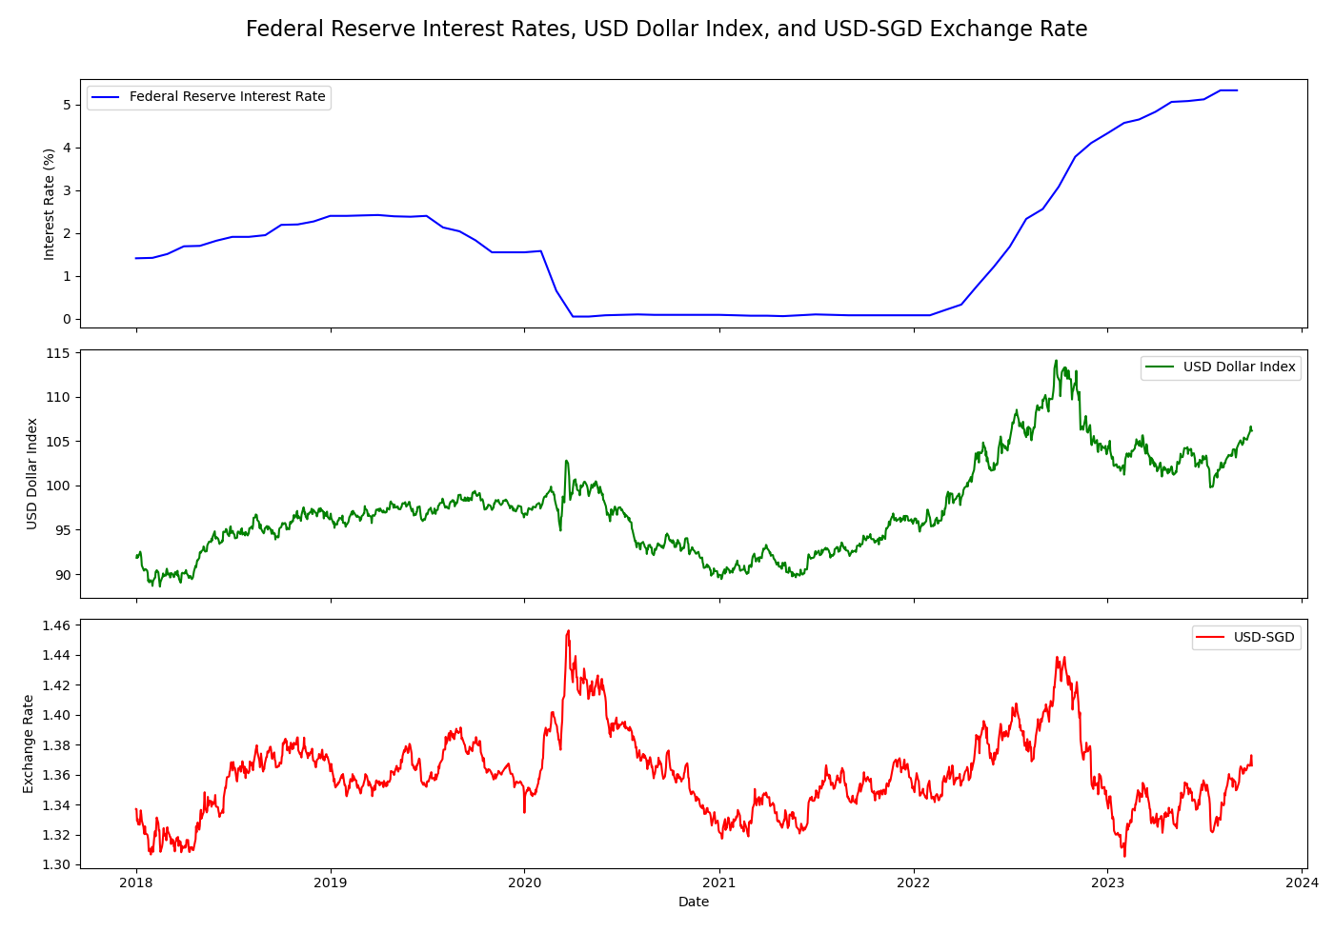
     2. 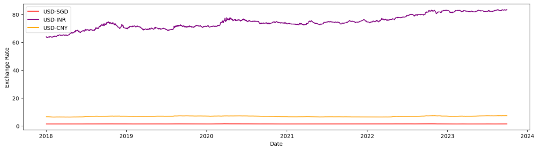
     3. For an investor leveraging to buy Apple stock, the Federal Reserve interest rates, the USD dollar index, and the USD/SGD exchange rate can present multifaceted considerations. Federal interest rates impact the cost of borrowing; when rates are low, leveraging is relatively inexpensive, potentially enhancing investment capacities, whereas higher rates augment borrowing costs, squeezing profit margins.
     4. Concurrently, the USD dollar index, which encapsulates the dollar's value against a basket of international currencies like USD/SGD, USD/CNY, USD/INR exchange rate, critically impacts Apple's international business, affecting both revenues from global sales and costs for overseas operations and supply chains. A robust USD may suppress Apple's overseas earnings when converted back to dollars, whereas a weaker dollar could enhance them, thus indirectly influencing stock prices. Notable financial markets such as USD/SGD movements also impact investor sentiment and cross-border investment flows. The interconnectedness of these variables with Apple's performance and broader economic health necessitates a holistic approach to leveraging strategies, ensuring the investor is shielded optimally against unforeseen macroeconomic shifts.
     5. The fluctuating values of the Indian Rupee and the Chinese Renminbi impact Apple's production costs due to its extensive manufacturing and assembly operations in these countries. Variations in these currencies against the USD alter input costs, affecting profit margins. Additionally, currency risk emerges, as currency value fluctuations can unpredictably influence revenues and expenses in these regions, impacting Apple's financial performance and, subsequently, its stock price, becoming a vital consideration for investors.
     6. 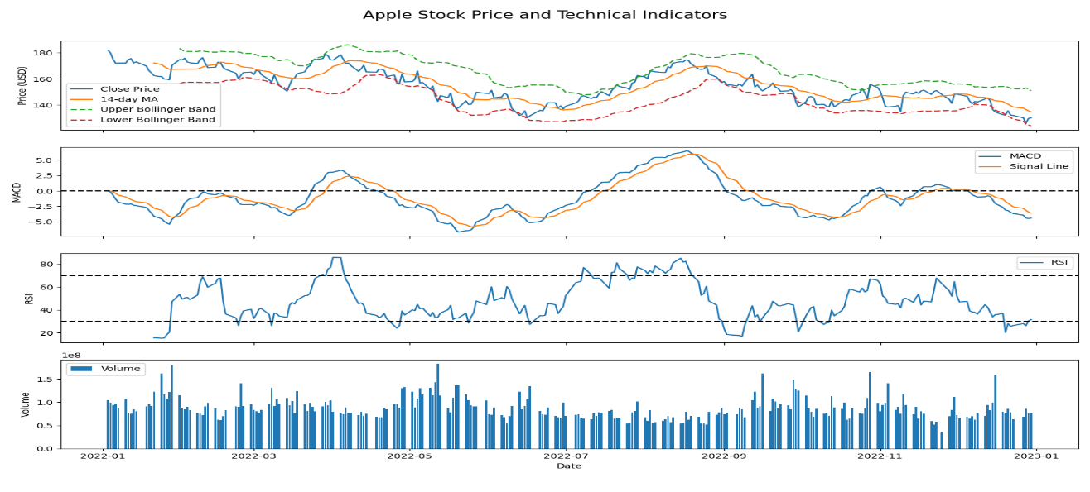
     7. The Relative Strength Index RSI, Moving Average Convergence Divergence MACD, Bollinger Bands BB, 14-day Moving Average 14DMA, and trading volume T.V. assist as potent technical indicators to scrutinize in terms of volatility and non-linearity embedded within Apple's historical stock price. The RSI helps gauge overbought or oversold conditions, revealing potential reversals or persistent trends in price, which may imply volatility or stability. MACD, with its convergence and divergence of short-term and long-term M.A., signals momentum and possible price reversals. Bollinger Bands encapsulate price within a range, with breakouts indicating volatility.

The 14DMA smoothens price data, offering a glimpse into prevailing trends and hinting at underlying non-linearity when juxtaposed with actual prices. Lastly, trading volume, especially when examined with price movements, can underscore the strength behind price changes, shedding light on possible speculative activity or genuine shifts in value, thereby revealing insights into potential volatility and non-linear dynamics in Apple's stock price movements.

* + 1. 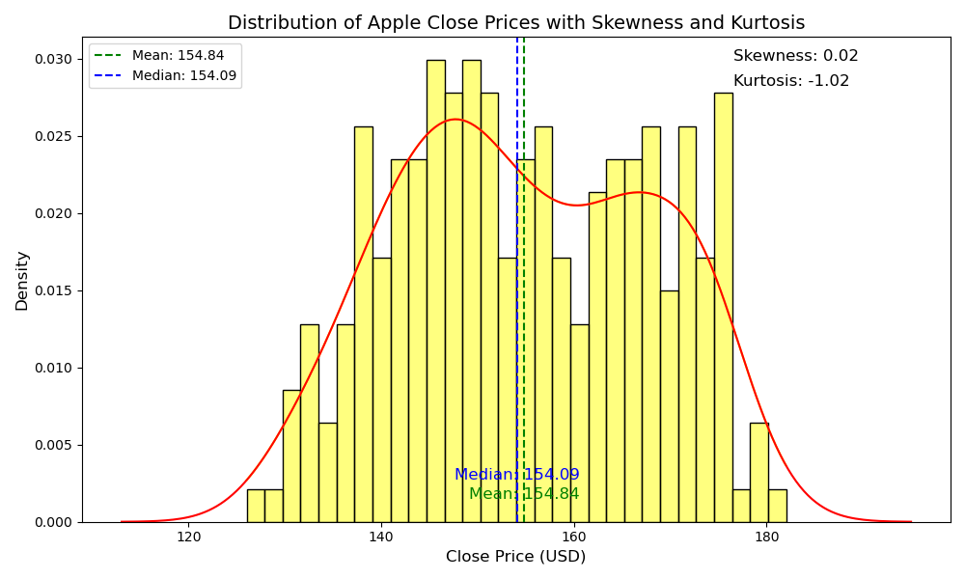
    2. Apple's historical stock data, presented by a mean of 154.84 and a median of 154.09, indicates the proximity of the mean and median alongside negligible skewness of 0.02 affirms a reasonably balanced and symmetric distribution of stock prices around the mean, with neither significant tails nor a pronounced bias towards higher or lower values. Although Apple has a bimodal distribution, it implies the existence of two prominent peaks in the stock price distribution, hinting that Apple’s stock price may have oscillated between dual and dominant price regimes over the assessed historical period. The kurtosis of -1.02, being platykurtic, implies a distribution with lighter tails and fewer outliers, revealing that the stock’s returns may not experience extreme values frequently. The platykurtic nature (-1.02 kurtosis) speaks to a distribution with lighter tails and fewer extreme outliers, possibly signaling less susceptibility to abrupt, extreme price shifts. However, the bimodal nature introduces an element of non-linearity, suggesting that Apple's stock price has experienced varied behavior or regimes precipitated by underlying factors or events that warrant closer examination to apprehend the dynamics influencing these disparate modes in pricing patterns.
    3. GWP1 probe into Apple's quarterly earnings reports offers insights into its revenue, profit margins, and net income
    4. GWP2 examines technical indicators like Bollinger Bands, Relative Strength Index, Moving Average Convergence Divergence, and 14-day Moving Average, along with the Dollar Index and international exchange rates, can improve Apple equity investment insights by offering both short-term trading signals and long-term trend analyses. This multifaceted approach helps investors assess volatility, momentum, and relative strength and understand broader economic factors affecting Apple.
  1. **Student: Yhasreen - Bond Investment Data insights:**
     1. 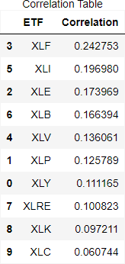
     2. 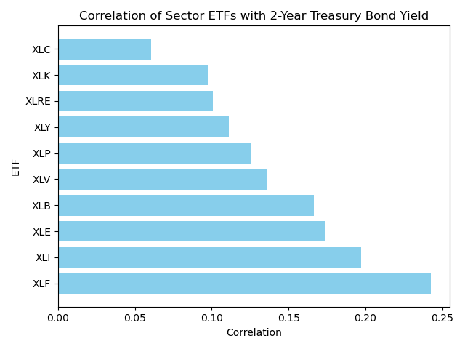
     3. The correlations between the ETFs, namely XLF, XLI, XLK, and XLC and the 2-year Treasury bond yield present varied degrees of association with fixed-income instruments, thereby crafting distinct potential investment strategies.
     4. XLF, with the highest correlation of 0.242753, signifies a more pronounced relationship with the Treasury yield, hinting that the financial sector influences short-term interest rate movements. XLI and XLK, with correlations of 0.196980 and 0.097211, respectively, present moderate to low correlations, suggesting that the industrial and technology sectors might offer some degree of diversification away from the direct movements of 2-year Treasury yields, although with some residual sensitivity.
     5. XLC, with the lowest correlation of 0.060744, might be a potential diversification tool during specific market conditions. An investor might leverage these correlations in crafting a diversified portfolio, aligning exposures across sectors with anticipated movements in 2-year Treasury yields to modulate risk and return strategically across various market conditions.
     6. 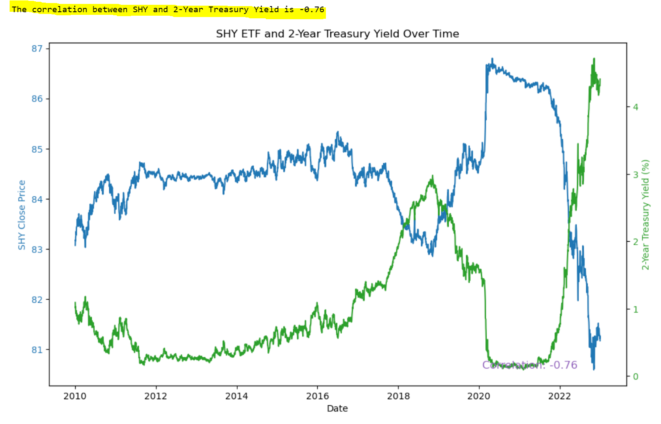
     7. A notable negative correlation of -0.76 between SHY (iShares 1-3 Year Treasury Bond ETF) and the 2-Year Treasury Yield suggests that as yields increase, the value of SHY typically decreases, and vice versa. Investors can employ a hedging strategy by taking positions in SHY to counterbalance their exposure to interest rate risks in their portfolios.
     8. 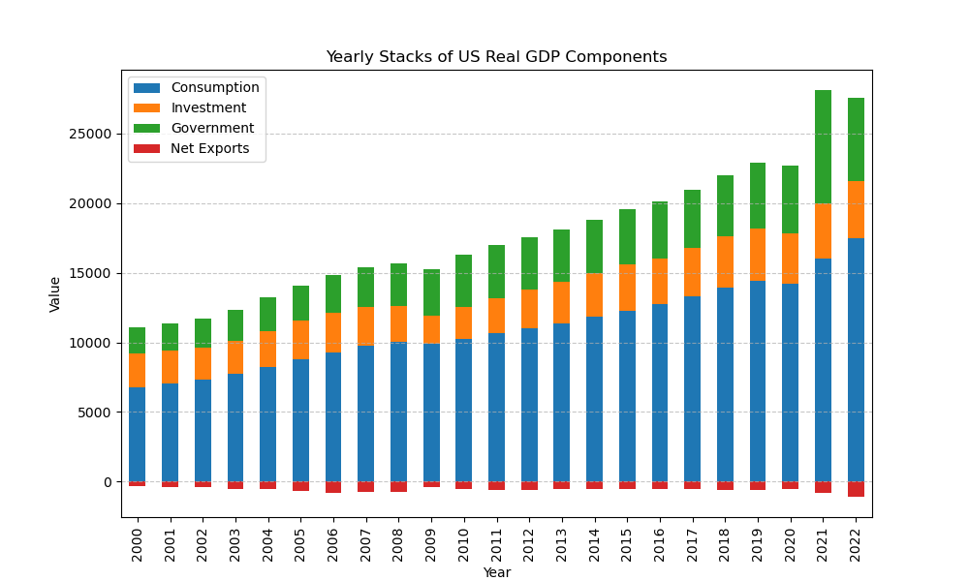
     9. 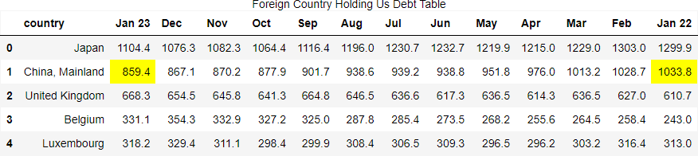
     10. The dynamics between the U.S. Debt, U.S. Trade, and the U.S. 2-year Treasury bond are multifaceted and profoundly interlinked. The substantial drop in China's holding of U.S. debt, from USD 1.033 trillion in Jan 2022 to USD 859.4 billion in Jan 2023, manifests a tangible shift in the geopolitical and economic landscape and could have implications for bond yields and interest rates.
     11. Concurrently, with U.S. trade imports soaring to USD 3.767 trillion and exports incrementally edging to USD 744 million, the widening trade deficit may exert pressure on the dollar, potentially impacting inflation rates. The ramifications of these developments on the U.S. 2-year Treasury bond are complex.
     12. The substantial shedding of U.S. debt by China, coupled with the growing trade deficit and trade tensions, could lead to upward pressure on bond yields to attract buyers. Consequently, the outlook for bonds may be harmful, reflecting apprehensions regarding the U.S.'s escalating debt and potential inflationary impacts.
     13. GWP1 delve into CPI, unemployment rate, savings, and the inverted yield curve which can improve bond investment insights by helping investors gauge the current and future economic conditions, interest rate trends, and credit risk. These indicators can assist in making informed decisions about bond types, maturities, and credit quality suitable for investment.
     14. GWP2 looks at all relevant U.S. sector ETFs, foreign debt holdings, and U.S. real GDP components that can improve bond investment insights by offering a multi-dimensional economic landscape. An economic view gives a comprehensive approach that can help investors identify macroeconomic trends, assess market risks, and allocate their investments more effectively.
  2. **Student: Ebenezer - Illiquid security Investment data insights**

In my analysis, I decided to utilize the VIX (volatility index) and the volume traded data for real estate investments, specifically focusing on property type, residential type, sales amount, addresses, and towns. These data sets have provided valuable insights into addressing the financial challenge of managing illiquid real estate assets.

In addition to the VIX as a measure of market volatility, I incorporated data specific to real estate investments, including property type, residential type, sales amount, addresses, and towns. This data is particularly valuable as it allows us to segment the real estate market and gain insights into how different types of properties in various locations respond to market volatility.

Upon analyzing these data sets, I observed a multifaceted relationship between the VIX and the liquidity of different types of real estate investments. When the VIX increases, indicating higher market volatility, the trading volumes and liquidity of certain types of properties may be more affected than others. For example, high-end residential properties in specific towns might experience more pronounced liquidity challenges during market turmoil.

This multi-dimensional relationship is highly significant in addressing the financial challenge of managing illiquid real estate assets. Real estate investments vary widely in terms of property type, location, and residential type, and these factors can influence how they respond to changes in market volatility. By understanding how different segments of the real estate market react to the VIX, we can make more informed investment decisions and develop strategies tailored to specific property types and locations.

The data-driven approach allows us to proactively manage the challenges associated with illiquid real estate assets. For instance, when we observe a spike in the VIX, we can analyze our real estate portfolio in more detail. If we find that high-end residential properties in certain towns are particularly vulnerable to liquidity issues during volatile market conditions, we can consider diversifying our portfolio or adjusting our real estate investment strategies accordingly.

In this way, the data sets, including property type, residential type, sales amount, addresses, and towns, along with the VIX and volume traded data, help us address the challenge of managing illiquid real estate assets comprehensively. They provide a practical tool for monitoring and managing the impact of market volatility on different segments of our real estate investment portfolio.

These insights build upon the findings from GWP1, where we gained a deeper understanding of volatility and its effects on investment strategies. In GWP2, by incorporating real estate data, we now have a more comprehensive view of liquidity dynamics within the real estate market, allowing us to make more precise investment decisions based on property type, location, and residential type.

The data sets selected and analyzed in both GWP1 and GWP2 have enhanced our ability to address financial challenges, particularly when dealing with illiquid real estate assets. By using the VIX, volume traded data, and real estate-specific information, we have gained valuable insights into how market volatility affects different segments of the real estate market, empowering us to make more informed and tailored investment decisions within this unique asset class.

1. **Reference:**
   1. Federal Reserve Bank of St. Louis. (2023). Mortgage Debt Service Payments as a Percent of Disposable Personal Income. Retrieved from https://fred.stlouisfed.org/series/MDSP
   2. Federal Reserve Bank of St. Louis. (2023).30-Year Fixed Rate Conforming Mortgage Index: Loan-to-Value Greater Than 80, FICO Score Between 720 and 739. Retrieved from https://fred.stlouisfed.org/series/OBMMIC30YFLVGT80FB720A739
   3. Federal Reserve Bank of St. Louis. (2023). Consumer Debt Service Payments as a Percent of Disposable Personal Income. Retrieved from https://fred.stlouisfed.org/series/CDSP
   4. Liberto, Daniel. (2023, June 28). House Price Index (HPI). Investopedia. https://www.investopedia.com/terms/h/house-price-index-hpi.asp
   5. OpenAI. (2023). ChatGPT (Mar 14 version) [Large language model]. https://chat.openai.com/chat
   6. Federal Reserve Bank of St. Louis. (2023). Real Estate Loans: Commercial Real Estate Loans: Construction and Land Development Loans, Small Domestically Chartered Commercial Banks.

https://fred.stlouisfed.org/series/CLDSCBW027SBOG

* 1. Federal Reserve Bank of St. Louis. (2023). Interest Rates and Price Indexes; Commercial Real Estate Price Index, Level https://fred.stlouisfed.org/series/BOGZ1FL075035503Q
  2. Federal Reserve Bank of St. Louis. (2023). Federal Funds Effective Rate https://fred.stlouisfed.org/series/FEDFUNDS
  3. **Student: Yhasreen for Magnifying Risk: Equity & bond**
     1. What Is Margin Trading? How It Works, Examples, Benefits, Risks

<https://fortunly.com/articles/how-margin-trading-works/>

* + 1. What is margin trading?

<https://www.futunn.com/en/learn/detail-what-is-margin-trading-62010-0>

* + 1. Investing to Yield Tax Savings

https://thestockwatcher.com/pages/articles/popular/2023/2/5/investing-yield-tax-savings

* + 1. Momentum and FOMO can drive stocks even higher

but the buying frenzy might end abruptly, Wharton's Jeremy Siegel says

<https://finance.yahoo.com/news/momentum-fomo-drive-stocks-even-222211481.html>

* + 1. Amundi warns on hidden leverage in the financial system

<https://www.ft.com/content/4dfd546b-bff6-4dfa-a858-06b855001faa>

* + 1. Leveraged ETFs: The Data Says We Are Missing Out

https://www.linkedin.com/pulse/leveraged-etfs-data-says-were-missing-out-christian-knapp/

* + 1. Bond Convexity: What Is It, and Why Should You Care? Brian Haughey. 2018.

https://www.cannonfinancial.com/uploads/main/bond-convexity-what-is-it-and-why-should-you-care.pdf

* + 1. Convexity in Bond

<https://www.financestrategists.com/wealth-management/bonds/convexity-in-bond/>

* 1. **Student: Yhasreen for Frictional Risk: Equity & bond**
     1. 2010 Flash Crash

<https://corporatefinanceinstitute.com/resources/equities/2010-flash-crash/>

* + 1. What is Flash Crash?

https://www.wallstreetmojo.com/flash-crash/

* + 1. Apple advances supplier clean energy commitments. Apple Newsroom.12 Sep 2023.

<https://www.apple.com/newsroom/2023/09/apple-advances-supplier-clean-energy-commitments/#:~:text=Apple%20today%20announced%20expanded%20progress,their%20Apple%20production%20by%202030>.

* + 1. Apple’s Carbon-Neutral Suppliers Have Doubled in Number. 27 Oct 2021.

<https://www.bloomberg.com/news/articles/2021-10-27/apple-says-it-has-doubled-number-of-carbon-neutral-suppliers?utm_medium=cpc_search&utm_campaign=NB_ENG_DSAXX_DSAXXXXXXXXXX_EVG_XXXX_XXX_Y0469_EN_EN_X_BLOM_GO_SE_XXX_XXXXXXXXXX&gclid=Cj0KCQjw1OmoBhDXARIsAAAYGSHZiHfMscDMn1DjbJDWoAgSuo3U7HGK04GSFNilYgQgRKwFiUMKm80aAgxoEALw_wcB&gclsrc=aw.ds&embedded-checkout=true>

* + 1. Apple will use 100 per cent recycled cobalt in batteries by 2025. Apple press release. 13 Apr 2023.

<https://www.apple.com/sg/newsroom/2023/04/apple-will-use-100-percent-recycled-cobalt-in-batteries-by-2025/>

* + 1. Apple to use recycled cobalt in batteries by 2025. 13 Apr 2023.

<https://www.reuters.com/technology/apple-use-100-recycled-cobalt-batteries-by-2025-2023-04-13/>

* + 1. Why your iPhone 17 might come with a recycled battery. 20 Apr 2023.

<https://www.technologyreview.com/2023/04/20/1071825/apple-cobalt-battery-recycling/>

* + 1. All new Apple batteries will use 100% recycled cobalt by 2025. 13 Apr 2023.

<https://techcrunch.com/2023/04/13/all-new-apple-batteries-will-use-100-recycled-cobalt-by-2025/>

* + 1. Bureau of International Labor Affairs. BOILA.

Combatting Child Labor in the Democratic Republic of the Congo’s Cobalt Industry (COTECCO)

<https://www.dol.gov/agencies/ilab/combatting-child-labor-democratic-republic-congos-cobalt-industry-cotecco>

* + 1. The iPhone 12 emits too much radiation, and Apple must take it off the market. French agency says.

<https://apnews.com/article/france-apple-iphone-radiation-b51b82309100f959c83a2a19536dc934>

* + 1. France bans iPhone 12 sales over radiation levels: Here is what you know. 14 Sep 2023. https://www.washingtonpost.com/wellness/2023/09/14/france-ban-iphone-12-radiation-levels/
    2. E.U. has forced Apple to switch to USB C in iPhone 15. Here is why the change in charging ports has global ramifications. 15 Sep 2023.

<https://indianexpress.com/article/explained/explained-sci-tech/eu-apple-charger-new-iphone-15-8939493/>

* + 1. With Apple's iPhone 15, the E.U. wins the charger war. 12 Sep 2023.

<https://www.politico.eu/article/apple-iphone-15-european-union-regulations-charger-usbc-lightning/>

* + 1. Apple to put USB C Connectors in iPhone to comply with E.U. Rules. 26 Oct 2022.

<https://www.theguardian.com/technology/2022/oct/26/iphone-usb-c-lightning-connectors-apple-eu-rules>

* + 1. The Basel Committee - overview

<https://www.bis.org/bcbs/#:~:text=The%20Basel%20Committee%20on%20Banking,cooperation%20on%20banking%20supervisory%20matters>.

* 1. **Student Yhasreen for Data Characteristics/ Collection Challenges / Insights - Equity:**
     1. Correlation and causation

<https://www.abs.gov.au/statistics/understanding-statistics/statistical-terms-and-concepts/correlation-and-causation#:~:text=A%20correlation%20between%20variables%2C%20however,relationship%20between%20the%20two%20events>.

* + 1. Understanding the difference between correlation and causation

https://dovetail.com/research/correlation-vs-causation/

* 1. **Student Yhasreen for Data Characteristics/ Collection Challenges/Insights - Bond:**
     1. Lies, Damn Lies, and Misleading Defense Statistics

<https://www.forbes.com/sites/williamhartung/2021/05/12/lies-damn-lies-and-misleading-defense-statistics/?sh=70dec2677d11>

* + 1. Do not Be Fooled by Biden's Budget: He is Cutting Military Spending as Our Needs Grow

<https://www.aei.org/op-eds/dont-be-fooled-by-bidens-budget-hes-cutting-military-spending-as-our-needs-grow/>

* + 1. Biden’s Defense Budget Draws GOP Criticism, Sets Up Spending Clash

<https://www.wsj.com/articles/bidens-defense-budget-draws-gop-criticism-sets-up-spending-clash-55df9493>

* + 1. The Pentagon does not need $886bn.

<https://www.theguardian.com/commentisfree/2023/jul/24/the-pentagon-doesnt-need-886bn-i-oppose-this-bloated-defense-budget>

* + 1. Fitch Downgrades the United States' Long-Term Ratings to 'AA+' from 'AAA'; Outlook Stable

<https://www.fitchratings.com/research/sovereigns/fitch-downgrades-united-states-long-term-ratings-to-aa-from-aaa-outlook-stable-01-08-2023>

* + 1. U.S. Treasury Yields hit 2023 highs after Fitch downgrades.

<https://www.bloomberg.com/news/articles/2023-08-02/treasury-10-year-yield-flirts-with-highest-level-since-november?embedded-checkout=true>

* + 1. China's holdings of U.S. debt fell below $1 trillion for the first time since 2010

https://www.cnbc.com/2022/07/18/china-holdings-of-us-debt-fall-below-1-trillion-for-the-first-time-since-2010.html

* + 1. Government expenditure, per cent of GDP

<https://www.imf.org/external/datamapper/exp@FPP/USA/FRA/JPN/GBR/SWE/ESP/ITA/ZAF/IND>

* + 1. How much has the U.S. government spent this year?

<https://fiscaldata.treasury.gov/americas-finance-guide/federal-spending/>

* + 1. Countries with the highest military spending worldwide in 2022

<https://www.statista.com/statistics/262742/countries-with-the-highest-military-spending/>

* + 1. U.S. defense spending

<https://www.pgpf.org/chart-archive/0053_defense-comparison>

* + 1. Global Military budget.

<https://power.lowyinstitute.org/data/military-capability/defence-spending/military-expenditure-defence-sector-ppp/>

* + 1. U.S. Department of Education.

Biden-Harris Administration Announces an Additional $9 Billion in Student Debt Relief

<https://www.ed.gov/news/press-releases/biden-harris-administration-announces-additional-9-billion-student-debt-relief#:~:text=Today's%20announcement%20brings%20the%20total,Public%20Service%20Loan%20Forgiveness%20programs>.

* + 1. Other visual data
       1. <https://www.visualcapitalist.com/which-countries-hold-the-most-us-debt/>
       2. <https://ticdata.treasury.gov/Publish/mfh.txt>
       3. <https://usafacts.org/articles/which-countries-own-the-most-us-debt/>
       4. https://www.visualcapitalist.com/us-largest-trading-partners-2022/